**Input and Output**

*The purpose of this assignment is to give you practice writing programs with input and output, including standard output, standard input, and standard drawing.*

1. **Shannon entropy.** Write a program ShannonEntropy.java that takes a command-line integer *m*; reads a sequence of integers between 1 and *m* from standard input; and prints the Shannon entropy to standard output, with 4 digits after the decimal point. The *Shannon entropy* of a sequence of integers is given by the formula:

H=−(p1log2p1+p2log2p2+…+pmlog2pm)

where pi denotes the proportion of integers whose value is i. If pi=0, then treat pilog2pi as 0.

~/Desktop/io> javac-introcs ShannonEntropy.java

~/Desktop/io> cat fair-coin.txt

1 1 1 1 2 1 2 1 1 2

2 2 2 2 1 2 1 2 2 1

~/Desktop/io> java-introcs ShannonEntropy 2 < fair-coin.txt

1.0000

~/Desktop/io> cat loaded-die.txt

3 2 6 2 4 3 2 1 2 2 1 3 2 3 2 2

~/Desktop/io> java-introcs ShannonEntropy 6 < loaded-die.txt

1.8750

~/Desktop/io> java-introcs DiscreteDistribution 1000000 80 20 | java-introcs ShannonEntropy 2

0.7221

~/Desktop/io> java-introcs DiscreteDistribution 1000000 80 20 | java-introcs ShannonEntropy 2

0.7217

*Step-by-step calculation.* Consider the following sequence of 16 integers generated from a loaded die.

3   2   6   2   4   3   2   1   2   2   1   3   2   3   2   2

This table shows the frequencies xi, the proportions pi, and the −pilog2pi  terms:

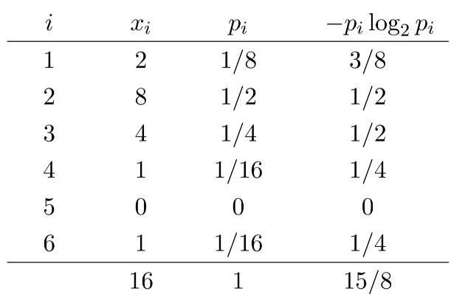

The Shannon entropy is 1.875 = 15/8.

*The Shannon entropy is a measure of the rate of information produced by a random source, such as the outcomes of flipping a fair coin or rolling a loaded die. It is a fundamental concept in information theory and data compression.*

1. **Checkerboard.**  Write a program Checkerboard.java that takes a command-line integer *n* and plots an *n*-by-*n* checkerboard pattern to standard drawing. Color the squares blue and light gray, with the bottom-left square blue. To draw,
   * Call StdDraw.setScale(0, n) so that *x*- and *y*-coordinates of the canvas range from 0 and *n*.
   * Call either StdDraw.filledSquare() or StdDraw.filledPolygon() to draw each of the *n*2 squares.
   * Make sure that the squares fit snugly in the standard drawing window.
   * Do not change the canvas size.

~/Desktop/io> javac-introcs Checkerboard.java

~/Desktop/io> java-introcs Checkerboard 8

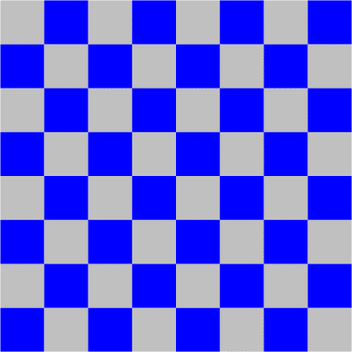

~/Desktop/io> java-introcs Checkerboard 4

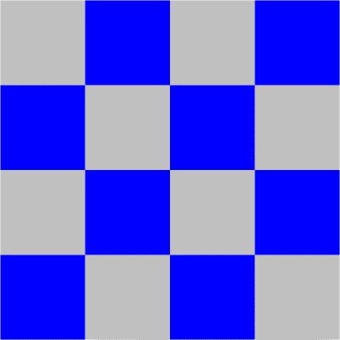

~/Desktop/io> java-introcs Checkerboard 5



1. **World maps.** Write a program WorldMap.java that reads boundary information of a country (or other geographic entity) from standard input and plots the results to standard drawing. A country consists of a set of regions (e.g., states, provinces, or other administrative divisions), each of which is described by a polygon.

*Input format.*   The first line contains two integers: *width* and *height*. The remaining part of the input is divided into regions.

* + The first entry in each region is the name of the region. For simplicity, names will not contain spaces.
  + The next entry is an integer specifying the number of vertices in the polygon describing the region.
  + Finally, the region contains the *x*- and *y*-coordinates of the vertices of the polygon.

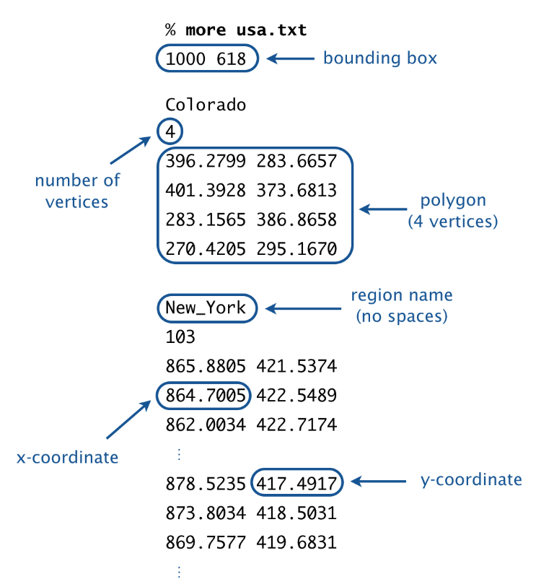

For simplicity, if a region requires more than one polygon to describe its boundary, we treat it as multiple regions, with one polygon per region.

*Output format.*   Draw the polygons to standard drawing, using the following guidelines:

* + Call StdDraw.setCanvasSize() to set the size of the canvas to be *width*-by-*height* pixels.
  + Call StdDraw.setXscale() and StdDraw.setYscale() so that *x*-coordinates of the canvas range from 0 to *width* and the *y*-coordinates range from 0 to *height*.
  + Call StdDraw.polygon() to draw each polygon.

Here are some sample executions for the input files [usa.txt](https://coursera.cs.princeton.edu/introcs/assignments/io/files/usa.txt), [russia.txt](https://coursera.cs.princeton.edu/introcs/assignments/io/files/russia.txt), and [world.txt](https://coursera.cs.princeton.edu/introcs/assignments/io/files/world.txt). Additional input files are available for [100+ countries](https://coursera.cs.princeton.edu/introcs/assignments/io/files/world) and [all 50 U.S. states](https://coursera.cs.princeton.edu/introcs/assignments/io/files/usa).

~/Desktop/io> javac-introcs WorldMap.java

~/Desktop/io> java-introcs WorldMap < usa.txt

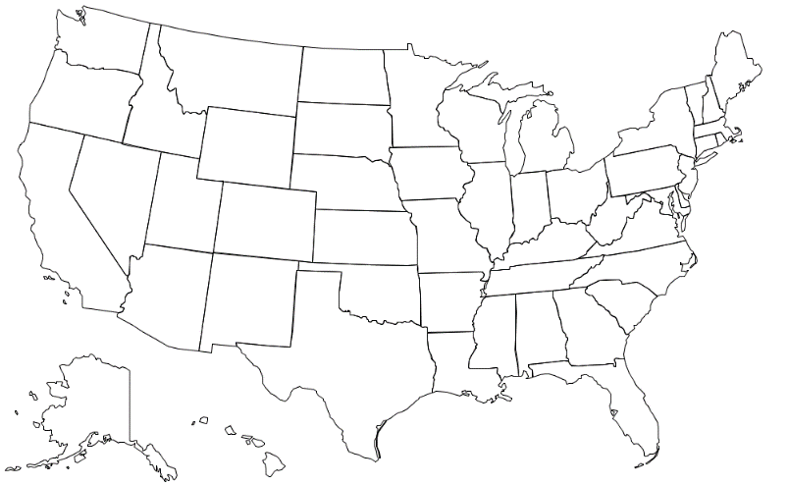

~/Desktop/io> java-introcs WorldMap < russia.txt

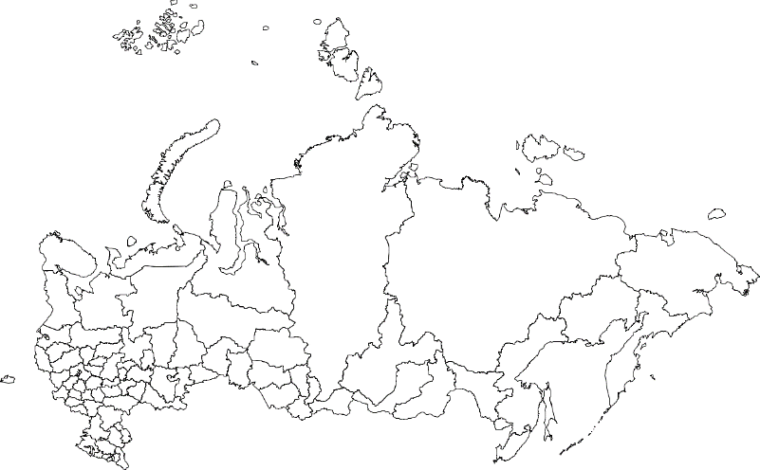

~/Desktop/io> java-introcs WorldMap < world.txt

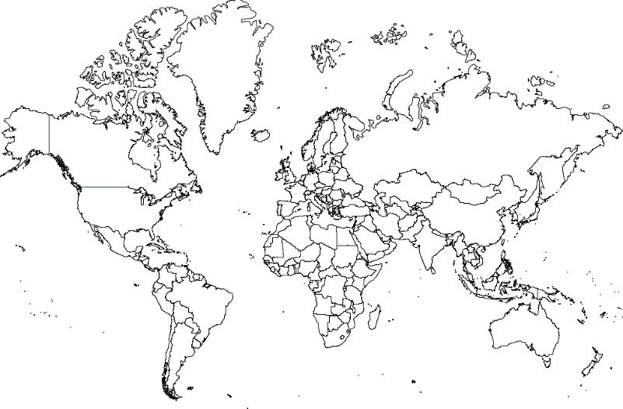

**Submission.** Submit a .zip file containing ShannonEntropy.java, Checkerboard.java, and WorldMap.java. You may not call library functions except those in the java.lang (such as Integer.parseInt() and Math.sqrt()) and stdlib.jar (such as StdIn.readInt() and StdDraw.polygon()). Use only Java features that have already been introduced in this course (e.g., loops and arrays, but not functions).